EXP NO:04 | STRING COLLECTION APPLICATION
DATE:16.8.19 | STRING COLLECTION APPLICATION

AIM:-
To create an array of strings where a string can be appended at the end,should be able to insert a string at a particular index, should be able to search for a string and sort a string with a letter starting at the first.

REQUIREMENT:-
-Should be able to append a string at the end
-should be able to insert a string at a particular index
-should be able to search for string
-should be able to sort a string with letter at first
-should be able to display the array of strings

ALGORITHM:-
STEP 1: create a package String
STEP 2: create a class named StringList
STEP 3:describe the structure of array of stings
STEP 4:Declare different cases for different conditions
STEP 5:mention the case for appending a string at the end
STEP 6:mention another case for inserting a string at a particular index and display the array of strings
STEP 7:mention another case for searching a string in the array and display search result with the index value of the string if the string is in the array or else print the string is unavailable
STEP 8:mention another case for sorting a string from array with a letter at first print the string if available or else print the string is not available
STEP 9: specify the condition for executing different cases
CLASS DIAGRAM:
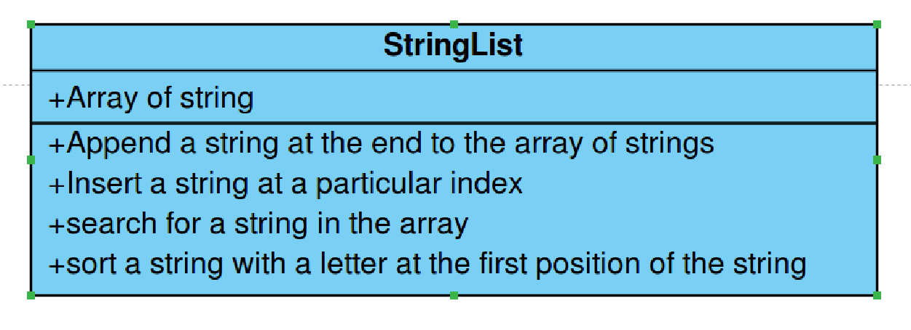
PROGRAM:
/***
*Created by Mari Bhagavathi.T
*212217105036
*mari36mars@gmail.com
*/
package String;
import java.util.*;
public class StringList {
public static void main(String[] args) {
// TODO Auto-generated method stub
int option;
int index,i;
String n;
Scanner sc=new Scanner(System.in);
ArrayList<String> strings;
strings=new ArrayList<String>();
while(true)
{
System.out.println("1. To add a string at the end");
System.out.println("2. To insert a string at particular index");
System.out.println("3. To search for a string");
System.out.println("4. To display all the Strings");
System.out.println("5. To Display the strings starting with the given letter");
System.out.println("6. Exit");
System.out.print("Enter your choice:");
option=sc.nextInt();
switch(option) {
case 1:
System.out.print("Enter a String:");
n=sc.next();
strings.add(n);
System.out.println("The given string is added at the end");
break;
case 2:
System.out.print("Enter a string:");
n=sc.next();
System.out.print("Enter the index:");
index=sc.nextInt();
strings.add(index,n);
System.out.println("The given string is added at the given index");
break;
case 3:
System.out.print("Enter a strings:");
n=sc.next();
index=strings.indexOf(n);
if(index<0)
{
System.out.println("The given strings is not available in the list");
}else
{
System.out.printf("The strings %s is found at the index %s\n",n,index);
} break;
case 4:
System.out.println("The available numbers are:");
for(i=0;i<strings.size();i++)
{
System.out.println(strings.get(i));
} break;
case 5:
System.out.println("Enter the first letter character");
n=sc.next();
for(i=0;i<strings.size();i++)
{
if(strings.get(i).startsWith(n))
{
System.out.println(strings.get(i));
} } break;
case 6:
System.out.println("Thankyou for using strings list application !!!");
break;
default:
System.out.println("Please enter a valid choice !!!");
}
if(option==6)
{ break;
}
}
}
}
OUTPUT:
- To add a string at the end
- To insert a string at particular index
- To search for a string
- To display all the Strings
- To Display the strings starting with the given letter
- Exit
Enter your choice:1
Enter a String:Lock
The given string is added at the end
- To add a string at the end
- To insert a string at particular index
- To search for a string
- To display all the Strings
- To Display the strings starting with the given letter
- Exit
Enter your choice:2
Enter a string: Hari
Enter the index:0
The given string is added at the given index
- To add a string at the end
- To insert a string at particular index
- To search for a string
- To display all the Strings
- To Display the strings starting with the given letter
- Exit
Enter your choice:5
Enter the first letter character
L
Lock
- To add a string at the end
- To insert a string at particular index
- To search for a string
- To display all the Strings
- To Display the strings starting with the given letter
- Exit
Enter your choice:6
Thank you for using strings list application !!!

RESULT:-
Hence, A java program is created for string collection application where string can be added to an array, a string can be inserted at particular index in the array, a string can be searched, a string can be sorted from array with a letter at first place in the string.

